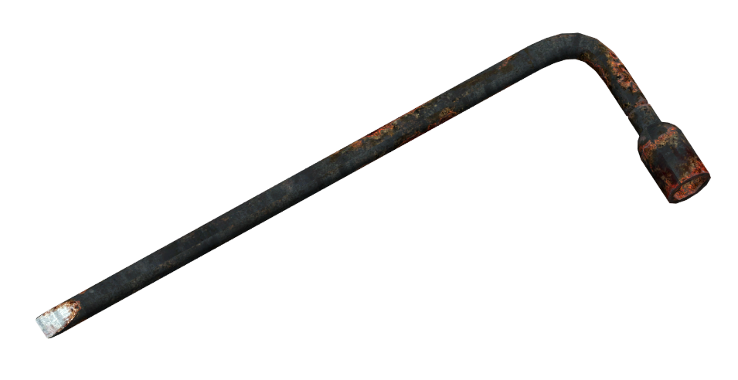

The Last Handful
of Clover

A Novel

by

Wess Mongo Jolley

Press Kit

Table of Contents:

Author Information: 3
General 3
Short Bio 3
Long Bio 4
Author Photos 6
Book Information: 7
General 7
Availability 7
Video Resources 7
Promotional Material: 8
Cover 8
Social Media Ads and Banners 9
Maps of the World 10
Back Cover Blurb 12
Character Sketches 13
Interview Resources 17
Press Release 21
Sample: Book 1, Chapter 1 — Tree of Blood 23
Sample: Book 3, Chapter 20 — The Only Other Thing He Cares About 33

Author Information:

General
Contact:
Name: Wess Mongo Jolley
Website: http://wessmongojolley.com
E-mail: mongo@wessmongojolley.com
Phone Number: 514-895-1391

Read:
Patreon: http://patreon.com/WessMongoJolley
Wattpad: https://www.wattpad.com/user/WessMongoJolley

Social Media:
Twitter: http://twitter.com/wessmongojolley
Facebook: http://facebook.com/wessmongojolley
LinkedIn: https://www.linkedin.com/in/wessmongojolley/
YouTube: https://www.youtube.com/user/mongobearwolf
SoundCloud: https://soundcloud.com/mongopoet

Short Bio
Wess Mongo Jolley is an expatriate American novelist, editor, poet and poetry promoter living in Montreal. He is the Founder and Executive Director of the Performance Poetry Preservation Project, and is best known for hosting the IndieFeed Performance Poetry Channel podcast for more than ten years.

As a poet, his work has appeared or is forthcoming in journals such as Off The Coast, PANK, The New Verse News, Danse Macabre, The November 3rd Club, The Legendary, decomP, Dressing Room Poetry Journal, RFD, TreeHouse Arts, Warrior Poets; and in collections such as the Write Bloody Press book The Good Things About America.

After a quarter century living on sixty acres in rural Vermont, he now writes and freelance edits full time from his balcony overlooking rush hour traffic in Montreal; a gorgeous, dirty, gritty, artsy, ecstatic, appalling, and vibrant beast of a city, which he loves the way you love a good-hearted uncle with Tourette’s.

He can be contacted by e-mail and through his website.

Long Bio
Wess Mongo Jolley is an expatriate American author, editor, and poetry promoter, living in Montréal.

Born and raised in Utah, Mongo grew up in Park City, a mining and ski town thirty minutes outside of Salt Lake City. He attended the University of Utah, majoring in Theater with an Acting Emphasis. During those early years he worked on many short stories, as well as Peace Reach, an autobiographical novel about his months-long 1984 solo excursion into the northern Canadian wilderness. He also wrote voluminous journals during several years of adventuring in the wilderness areas of the West, as well as over 4,000 miles of solo bicycle touring.

It wasn’t until more than a decade later that Mongo discovered what would become one of his greatest passions: poetry and spoken word.

It all began with the poet Allen Ginsberg, whose work has fascinated Mongo since he was a young adult. In 1995, he created the tribute website ginzy.com, which quickly grew to become the most respected and comprehensive source of information about Ginsberg on the internet. At the time of Ginsberg’s death in 1997, major media sources selected the site as a primary resource for information on the poet, and Mongo became key in organizing readings across the country to celebrate Ginsberg’s life. Ginzy.com was closed in 2001, as the rise of Google and other search engines made the clearinghouse nature of the site unnecessary.

In 2006, Mongo founded the IndieFeed Performance Poetry Channel, which featured the best spoken-word artists in the slam and performance poetry field. In the over ten years of podcasting that followed, IndieFeed featured over 600 poets and 1,600 episodes, with a total download count of over ten million episodes distributed. During that decade, the iTunes music store consistently listed the show as one of their top three poetry podcasts. The show is available in the IndieFeed Archives.

In 2010, Mongo founded the Performance Poetry Preservation Project (P4). This partnership between the poetry slam community and academia has ambitions to collect, preserve, protect, and provide access to the recorded history of the poetry slam movement. In 2017, P4 transferred its collection of many thousands of items and tens of thousands of performances to Dartmouth College’s Rauner Special Collections Library, and the organization continues to expand and build upon that collection. Discover more at the P4 website and browse the collection using the Dartmouth College Library Finding Aid.

In his non-literary life, Mongo is a Certified Records Manager and an information management professional with over thirty-five years of experience in the field. For twenty-two of those years, he was the Records Manager at Dartmouth College in Hanover, New Hampshire, where he also served for 18 months as the Interim Manager of the Rauner Special Collections Library. In these two roles, he nurtured a keen interest and built extensive experience in historical preservation issues, information technology, data system design, and digital record keeping. At his retirement in 2015, Dartmouth granted him the title of Records Manager Emeritus.

In the early 90s, prior to his work at Dartmouth, Mongo spent a half-dozen years as a Crisis Counselor and as the Data Management Coordinator for the California Runaway Hotline in Sacramento, California. During these years he also established a chapter of ACT/UP (the direct-action AIDS activist group founded by Larry Kramer); created Bear Byte Data Management (a relational database consulting business); and for several years was the Layout and Design editor of the legendary Pagan journal Green Egg, edited by Diane Darling and Oberon Zell. The deep connection he had during those years with The Church of All Worlds, and their nature sanctuary, Annwfn, has heavily influenced much of his writing.

Mongo’s poetry and other writings have appeared in Off The Coast, PANK, The New Verse News, Danse Macabre, The November 3rd Club, The Legendary, decomP, Dressing Room Poetry Journal, RFD, TreeHouse Arts, Green Egg, Warrior Poets, and in the Write Bloody Press book The Good Things About America. Audio versions of his poetry have been featured on the IndieFeed Performance Poetry Channel, and Cloudy Day Art. He has performed his work at many open mics across the country, including The Green Mill, The Bowery Poetry Club, The LouderArts Project, and the Nuyorican Poets Cafe.

Since his retirement from Dartmouth College, Mongo has freelanced through WMJ Manuscript Services as a manuscript consultant, specializing in helping poets craft their best manuscript out of a collection of poems. He has worked with prominent authors including Cristin O’Keefe Aptowicz, Derrick Brown, Anis Mojgani, and Jack McCarthy, among many others. In more recent years, he has offered his consulting, copy-editing, and proofreading services to prose writers as well.

For the past three years Mongo has been hard at work on what has become his most ambitious project yet: The sprawling supernatural horror novel, The Last Handful of Clover. Mongo describes the work as “an epic meditation on aging, loss, and regret,” and “perhaps the most challenging thing I have ever tried to write.”

In between these things, Mongo characterizes himself as a polyamorous queer faerie pagan poet bear. After a quarter century living on 60 acres in rural Vermont, he now lives with two of his three partners, and writes full time from a cubicle overlooking la Collection nationale in le Grand Bibliothèque de Montréal.

His website can be found at http://wessmongojolley.com, and you can reach him at mongo@wessmongojolley.com.

Author Photos
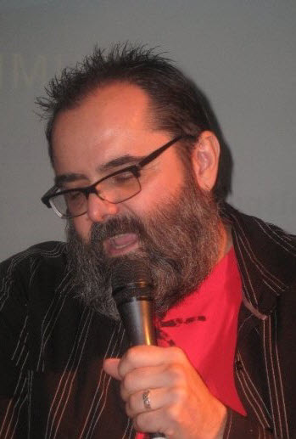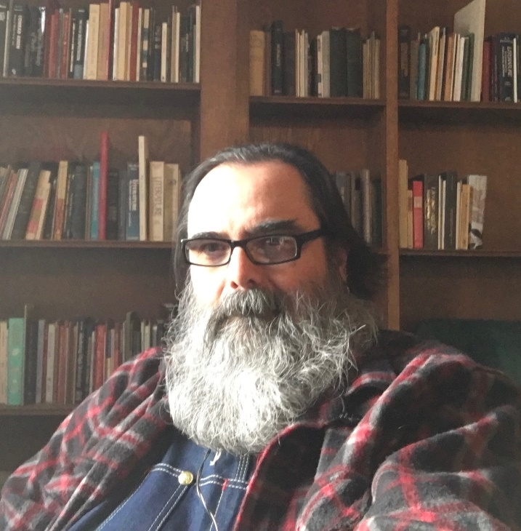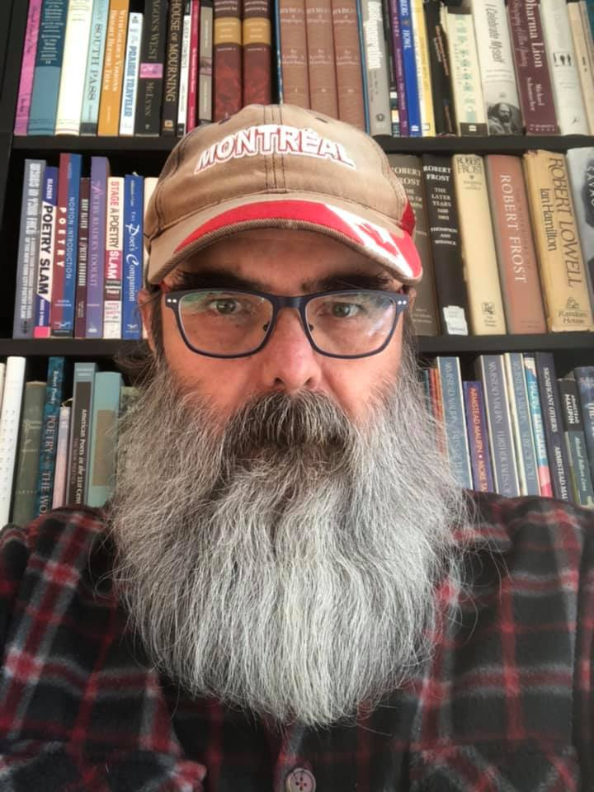

Book Information:

General
Name: The Last Handful of Clover
Author: Wess Mongo Jolley
Publication Date: Initial offering via Patreon begins May 15, 2021
Length: 517,000 words
207 chapters
3 volumes
Genre: Supernatural Thriller

Availability
Patreon: Starting May 15, 2021: http://patreon.com/wessmongojolley
Price: begins at $2.50 USD per month
Wattpad: Starting June 15, 2021: http://wattpad.com/wessmongojolley
Price: Free
Audio Podcast: Fall 2021
Price: Free

Video Resources
Patreon Introduction: https://youtu.be/fz1K1B_rWvo
Maps Discussion: https://youtu.be/wzSjgTYskTA

Promotional Material:

Cover
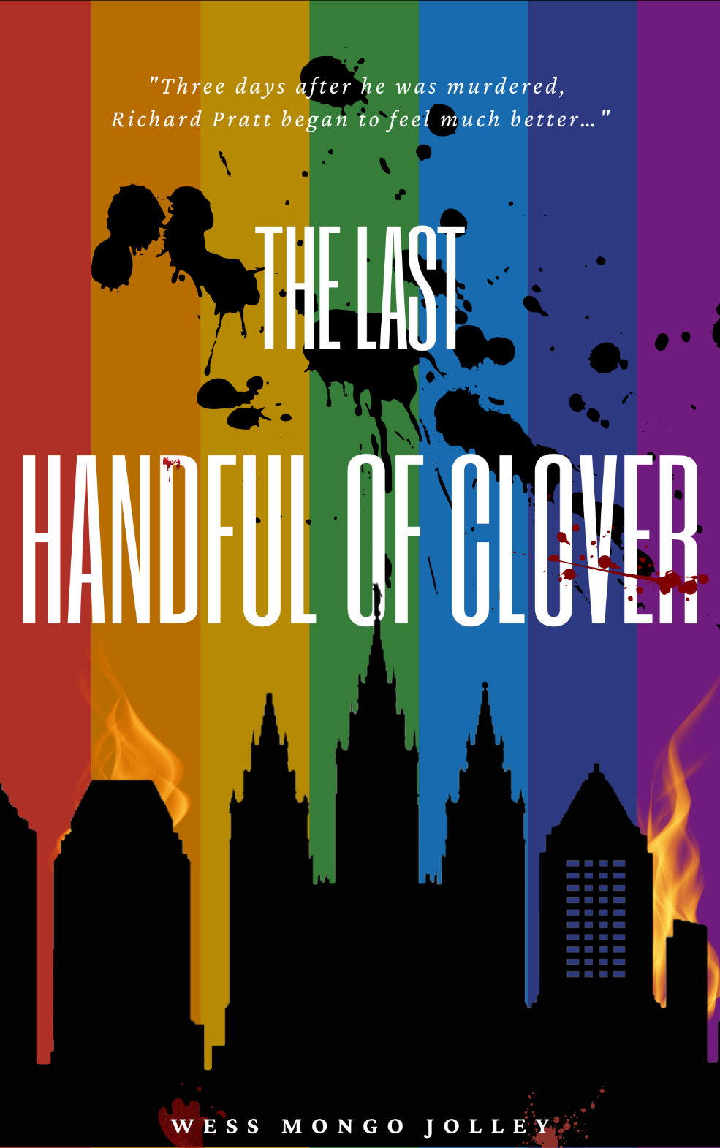

Social Media Ads and Banners
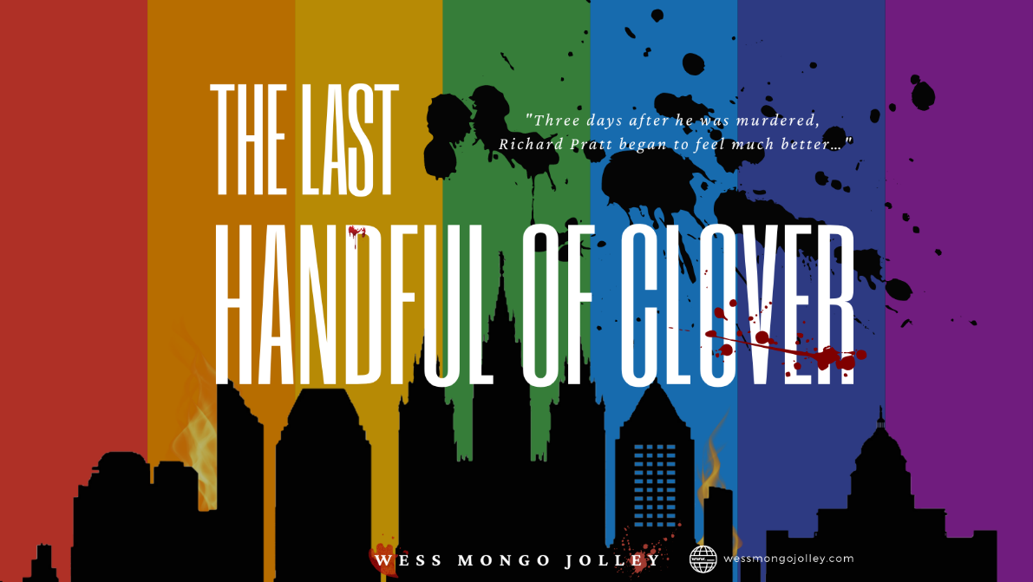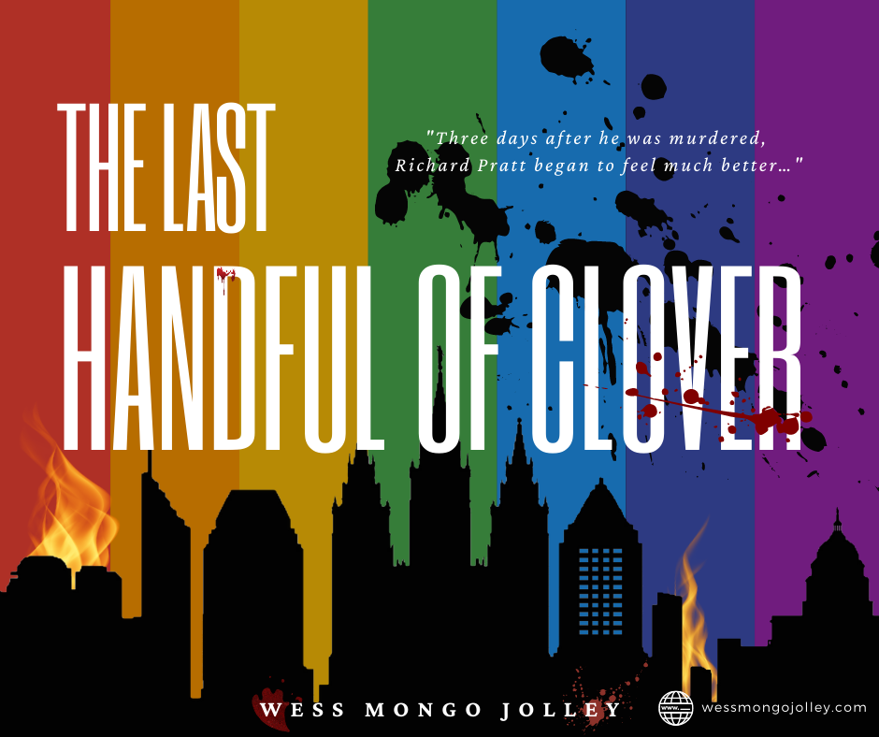

Maps of the World
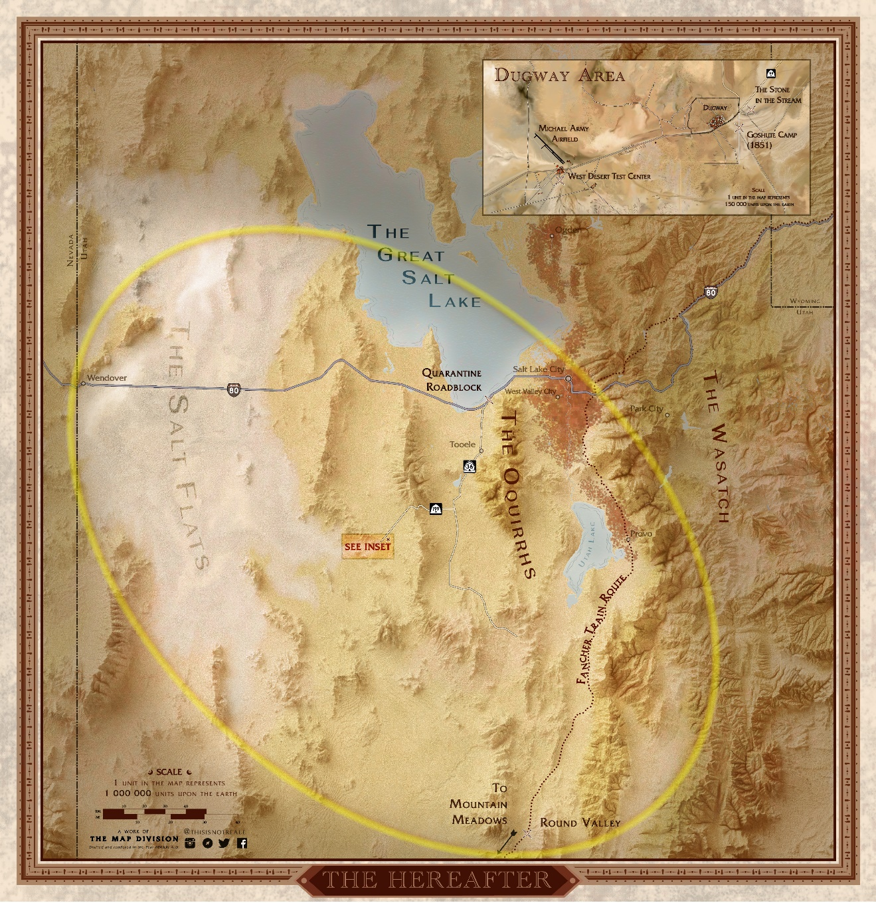
The Hereafter is the bubble between the worlds of the living and the dead. It is a hard boundary which the ghosts in the novel cannot cross. This map shows the extent of The Hereafter and other key locations important to the story. (Higher resolution map available upon request.)
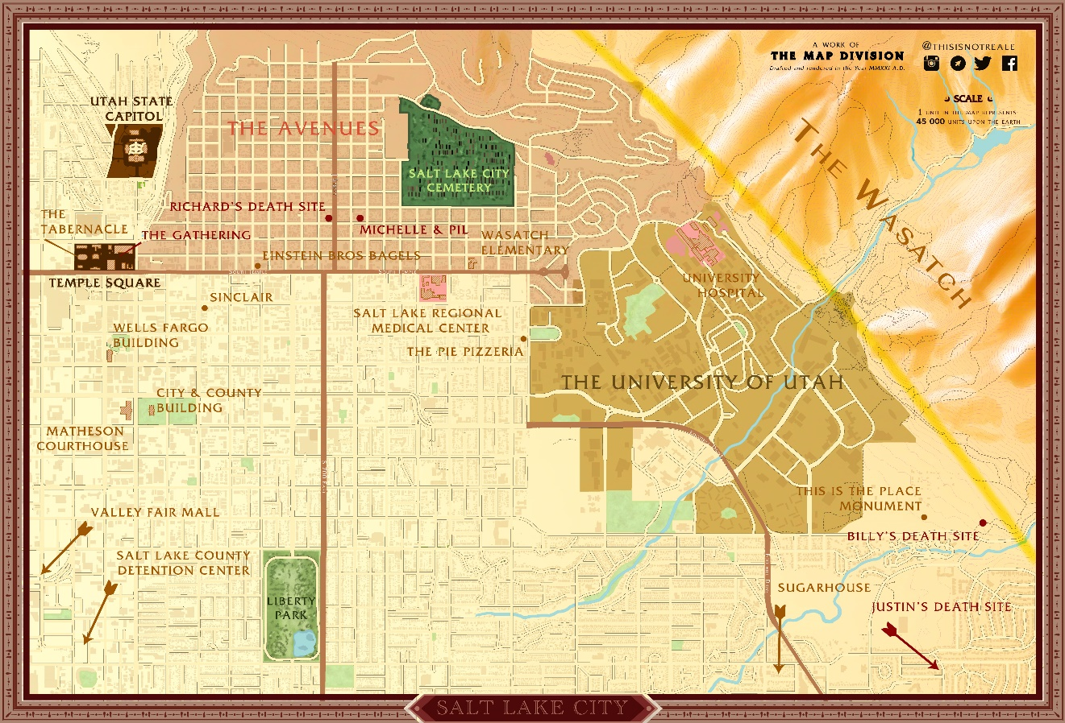

Most of the novel occurs in a small area of Downtown Salt Lake City—especially in the Avenues neighborhood, the University of Utah, and Temple Square. This map shows many of the key locations where the story unfolds. (Higher resolution map available upon request.)

A guided tour of the world, based on these maps and narrated by the author, is available at: https://youtu.be/wzSjgTYskTA

Back Cover Blurb
Three days after he was murdered, Richard began to feel much better…
A seemingly random act of violence propels Professor Richard Pratt into the Hereafter. It is a strange, muted, netherworld of the dead—a world in which he is forced to bear witness to the loss and suffering of the man he left behind, and to the rapid demise of the city he called home. And when the other denizens of his ghostly realm begin to enact a brutal revenge on the world of the living, it is only Richard Pratt that can save them.
With the help of a barefoot 15-year-old boy from the old West and an ancient Goshute wise woman, Richard Pratt sets out to save the man he loves, Salt Lake City, and his own wounded soul. Together they must face a ferocious enemy bent on the complete destruction of a great American city. An enemy with his fingers deep in Richard’s shameful past.
The Last Handful of Clover is a sweeping supernatural thriller about love, loss, regret, and redemption. It is a novel of terror, in which one man is called upon to face the sins of his past in order to save the future for the man he loves, and a city of over a million innocent souls.
Peopled by a cast of unforgettable characters, The Last Handful of Clover is an epic hero’s journey into darkness. From the remote Montana wilderness of 1810 to a secret chemical weapons laboratory under the Utah desert, the scope of The Last Handful of Clover is breathtaking, and lays bare the desperate longings, universal loss, and inevitable anguish of being human.

Character Sketches
The novel contains over fifty named characters, of which seventeen serve as point-of-view characters, creating a vivid, immersive world for the reader. Following is a list of all characters with at least one point-of-view scene:

The Dead:

Richard Pratt (57 at the time of his death, three days before the story begins): A professor of Linguistics at the University of Utah, the story begins with his murder: a single shot to the head, fired through his living room window. The shot kills him instantly, and he dies in in his husband’s arms. Three days later, Richard escapes the place he only knows as “The Void,” and begins his adventure into the netherworld of the living and the dead known in the novel as “The Hereafter.” Haunted by regret and guilt, we follow Richard as he attempts to right wrongs while he still can.

Billy Travers (15 at the time of his death in 1857): A young and idealistic boy when he and his family set off from their home in the Midwest for the gold fields of California, Billy Travers falls in love with Frances, the oldest daughter of the family he meets on the Oregon Trail. But an accident on the plains of Wyoming crushes Billy’s ankle, and he dies of sepsis just as his family enters the Salt Lake Valley. Like Richard a century and a half later, Billy is trapped in the Hereafter, and becomes a friend, confessor, and sage to Richard; much wiser than the innocent 15-year-old boy he was the year he died.

Justin Kimball (18 at the time of his death, 22 years before the time of our story): Justin is a young student at the University of Utah who had an ill-fated affair with his professor, Richard Pratt. Richard’s betrayal and Justin’s violent death have turned him into a ghost that is filled with rage and consumed with a need for revenge.
Justin has become one of the key disciples of The Wanderer, a dark and mythic figure who is bent on destruction of the Salt Lake Valley. Justin’s destiny is complicated, not only by his fury and unresolved feelings for Richard Pratt, but also by a deep obsession with Howard Gunderson; the boy he possessed as a tool to kill his old professor.

Mattie Sowersby (8 at the time of her death in 1857): Mattie is the younger sister of Frances Sowersby, whom Billy fell in love with before his death. A strange and shy girl, Mattie nurtured a crush on Billy during the brief time she knew him, before his accident. But she doesn’t realize that Billy’s ghost is still watching over her and her family later that summer when a pair of rogue bandits from a passing wagon train murder her entire family. She returns three days later, another prisoner of The Hereafter. But the trauma of her murder, and the fact that she returns and finds herself trapped in the cabin with the rotting bodies of herself and her family, conspire to permanently destroy Mattie’s sanity. By the time she is freed from the cabin, she has become easy pickings for The Wanderer, who calls her “Princess” and makes her one of the prime instruments of his vengeance.

The Wanderer (78 at the time of his death in 1847): George Drouillard (aka “The Wanderer”), is based on an actual historical figure. Drouillard was a guide for the Lewis and Clark expeditions, and a mountain man who, history tells us, died in 1810. However, for this story, George Drouillard faked his death in the Montana wilderness that year, and wandered into the Great Basin, where he was adopted by a tribe of Goshutes. There he met Tuilla, a widow with several children, who became his wife. It is the Goshute that give Drouillard the name “The Wanderer,” and in the last decades of his life, he becomes a respected elder of the tribe.
But in 1847, Drouillard, his family, and many elders and children of his tribe are killed by a marauding band of Mormons, led by Porter Rockwell. This, too, is based on an actual incident in Utah history, in which a posse of Mormons took vengeance on the Goshutes for allegedly stealing their horses. The massacre is so brutal, and Drouillard’s rage is so great, that his death causes a bubble to form between the world of the dead and the world of the living. From within that bubble, which comes to be known as “The Hereafter,” Drouillard snags the souls of the dead that will help him take his vengeance upon the people who he blames for the death of his family and tribe.
In 1969, The Wanderer possesses the body of a young boy named Sutton Deary, and by the time of our story, Deary has grown into a 62-year-old Corporal in the US Military, working as the head of security for the West Desert Test Facility. He has forgotten much about his origins, but not his hatred for everyone and everything in the Salt Lake Valley.

Tuilla (82 at the time of her death in 1847): Tuilla is the Goshute wife of The Wanderer and is caught up with him as the Hereafter is created. Tuilla is a wise, compassionate, and mysterious figure, who helps Richard and Billy as they struggle to save the Salt Lake Valley from the wrath of her deceased husband. Early on she befriends Billy and later identifies Richard as The Disruptor: the ghost whose power can save the entire Salt Lake Valley from The Wanderer’s vengeance.

The Living:

Keith Woo (32): Richard’s husband of ten years (and twenty-five years his junior), Keith is a quiet, shy, bookish man who is content to write poems in his journal and shelve books at the Marriot Library on the University of Utah Campus. Physically, Keith is short and round, with a soft face and gentle manner. After experiencing the murder of his lover in his arms, Keith struggles with depression and despair. But there is also a quiet strength and a level of introspection and introversion that helps him navigate his grief. His love and his faith in Richard are nearly enough to bridge the world of the living and the dead.

Michelle Kilani (33): Keith’s best friend since high school, Michelle has long been Keith’s self-appointed protector and confessor. The two have always been inseparable, even when Michelle returned early from her LDS Mission to Hawaii, towing her new fiancé.
Michelle has never really trusted Keith’s husband Richard, both because she sees him as arrogant and unapproachable, and because he was more than twice Keith’s age when the two men started dating. She’s done her best to be supportive of Keith’s life choices, but sometimes struggles to keep her opinions about Richard to herself.

Pi’ilani (Pil) Kilani (38): Pil met Michelle in Hawaii, when he was working as a performer at the Polynesian Culture Center. Pil is huge Maori man, weighing over 400 pounds, and is over six and a half feet tall. An intimidating presence, with his long, curly black hair, and his thick arms and chest completely covered with traditional Maori tattoos, his appearance belies the fact that he is among the gentlest of men. He’s been a devoted husband to Michelle, and is best known for his love of cats, which seem to gravitate to him wherever he goes. He’s exceptionally fond of Keith, to a degree that makes Michelle wonder if there might be feelings between the men that verge on the romantic. He is not as mistrustful of Richard as his wife is, but recognizes that he, Michelle, and Keith make up a family that Richard was never really a part of.

Howard Gunderson (20): There is something mystical, and almost holy, about Howard Gunderson. Howard is the boy who shot Richard Pratt, in an incident that he can’t remember. One moment he is just a happy twenty-year-old guy, still living at home with his parents, and then, after a night of joyriding with his friends, he wakes up on the lawn of a strange house, accused of murdering a man he has never met. He is determined to discover what has really happened to him, but doesn’t realize that he has a powerful adversary of his own. One who wants to possess him, body and soul. And one whose destiny is inextricably tied up with his own.

Carla Grayson (47): Detective Carla Grayson is the officer assigned to investigate the murder of Richard Pratt. During her investigation, she bonds with Howard Gunderson, the accused murderer. Carla is a widow with no children, but a strong matronly instinct that is triggered by Howard’s air of confusion and vulnerability. She makes it her goal to understand what happened to this strange boy, but she never dreams where that quest will take her.

Bradley Seward (40): Bradley is a pilot working out of Dugway and the West Desert Test Center. He brings his wife and two young girls into town for a weekend, which starts with a movie at a local multiplex. Bradley is possessed, and over the course of a few brief minutes he massacres a dozen teenagers in the dark theater. Like Howard, he doesn’t know what happened, but unlike Howard, Bradley takes his own life once he realizes what he has done. Unfortunately, the escape is brief, as The Wanderer calls him back to the Hereafter.

Morgan Jensen (38): Morgan is a hard-hitting and driven local reporter with a Salt Lake City television station. She and her cameraman are witness to the slow unraveling of life in Salt Lake City, as the Wanderer enacts his vengeance. Her fate comes to a head on the roof of the Wells Fargo Building, where her actions might spell life or death for hundreds of thousands.

Susan Jarvis (36): Sutton Deary’s secretary in his office in the West Desert Test Center, Susan has no idea that her boss is not who he appears to be, and that he has devised a role for her in the destruction of the Salt Lake Valley.

Gerry Anderson (46): After the city is put under quarantine, Corporal Gerry Anderson oversees a roadblock on Interstate-80, just outside of Salt Lake. His job is to ensure that nobody leaves the Salt Lake Valley. But he does not know that he and his unit stand between The Wanderer and his quarry.

Gus Humphreys (55 in 1857): Gus Humphreys is the trail boss for the cowhands of the Fancher Train, which is passing through Utah in 1857. Against his better judgement, Gus provides refuge for a disaffected Mormon “backout,” looking to escape the Salt Lake Valley. This leads to tragic results. Although Gus plays a small part in this story, he is the protagonist of a planned sequel.

Jacob Stauffer (28 in 1857): Known as “The Backout,” Jacob Stauffer is a disaffected Mormon whose wife has been stolen from him by a high-ranking Mormon official. He goes into hiding to escape the Danites, Brigham Young’s secret enforcers, who are known to murder “backout” Mormons who attempt to leave the Church.
Stauffer gets caught up in the murder of the Sowersby family along with another cowhand, who goes by the name of “The Dutchman.” It is Dutch who leads Stauffer into his participation in a monstrous crime.
Both characters play a larger role in a planned sequel.

Interview Resources
Tell us about your novel, The Last Handful of Clover.
The Last Handful of Clover is a supernatural thriller, set in Salt Lake City, and featuring a gay protagonist.
Mostly, I think of the story as a ride on an out-of-control freight train. It is an epic story of love, loss, regret, and redemption, but it is also an exciting read! Over the course of the novel, our protagonist (Richard Pratt) must face a great evil that is threatening the man he loves, as well as the city he calls home. If he can’t defeat this evil, it will literally swallow up everything and everyone he cares about.
This is especially complicated for Richard because he dies three days before the story begins. The story is told through both the eyes of the living and the eyes of the dead.

Is there an overall theme to the novel?
In the broadest sense the book is about aging, and the inevitable losses and regrets that come along with it. But it is also a story about how the sins of our past (both personal, and as a society) have repercussions that reverberate throughout time. The controlling idea of the novel is that healing and transcendence is possible only after we make the choice to accept and embrace what we have lost.

Why did you decide to make your protagonist gay?
I guess the simple answer is that you need to write what you know. I’m a gay man from Utah, so it felt like a good place to start!
But the more thoughtful answer is that I believe representation is important. I wanted to write a story where the lead characters were gay, and yet the story was also about truly universal experiences. The fact that the lead character is gay is crucial to the story, and it would not be the same story if the characters were straight. And yet there is much in Keith and Richard’s experience that everyone can relate to, no matter their orientation.
I think Richard and Keith’s relationship is one that gay men (especially bear-identified gay men of my generation!) will recognize and find familiar.

You’ve mentioned Richard Pratt. Who are the other major characters in the novel?
The book has a fairly large cast. There are seventeen point-of-view characters in the novel. Each of the over two hundred chapters is told through the eyes of one of these characters, and we get to meet a lot of the people who cross paths with Richard over the course of the three books.
Primary among these are Keith Woo (Richard’s Pratt’s grieving widower, who is twenty-five years his junior), Justin Kimball (a boy Richard loved and wronged many years before), Billy Travers (a barefoot fifteen-year-old boy from the old West), Mattie Sowersby (the eight-year-old daughter of a Mormon pioneer family), Howard Gunderson (the boy who murders Richard Pratt), Carla Grayson (the detective investigating Richard’s murder) and many others.
Obviously, some of these characters are alive, and others are ghosts. You’ll have to read the book to discover which is which.

How long have you been writing?
To be honest, I’ve been writing for as long as I can remember. I wrote many stories and 80% of a novel when I was in my twenties, before taking a many-decade-long detour into an academic career. I returned to writing seriously in my forties and focused primarily on poetry for more than a decade, getting some of my work published in literary journals, and hosting a podcast for performance poets. When I retired from my career in 2017, I was finally able to write full time, and it’s been a joy and a blessing.

How long did it take you to write this novel?
It’s a huge book, and it took almost five years. In fact, it’s being released on the five-year anniversary of the day I made the first notes on the story, which included the line that I still use when talking about the book: “Three days after he was murdered, Richard Pratt began to feel much better.” That line didn’t make it into the book, but it captured the spirit (no pun intended) of what I wanted to write.
Most of the writing on this book happened in Montreal, after my partner and I moved here in 2017. I’m especially grateful to la Collection nationale in le Grand Bibliothèque de Montréal, which is where I wrote the bulk of the latter half of the book, sitting in a cubicle overlooking their magnificent reading room. Until COVID, I went there to write pretty much every day.

Who do you hope will read this book?
Everyone! But I realize that a three-volume, half-million-word supernatural thriller with a gay protagonist won’t be everyone’s cup of tea.
I think you will love this book if you enjoyed Stephen King’s The Stand. It also has themes you’ll find in movies like The Others and The Sixth Sense (in that it is a ghost story told largely from the perspective of the ghosts).
Honestly, despite what many might see as a “niche appeal” for this book, I think it will appeal to a lot of readers. It’s a gay story, but it’s also a universal book about aging, loss, regret, and redemption. And who among us hasn’t struggled with those existential questions and experiences?

What is the best way to read the book?
I’ve made the unconventional choice to release the book to Patreon first, and I’m hoping that everyone will go there and become a patron. For the cost of a cup of coffee each month, you’ll get two chapters a week. And for just a few dollars more, you can listen to me narrate each of those chapters as well. I’ll be releasing the audio book chapters on Patreon simultaneously with the text chapters.
But more than just a place to read the book, my dream is that we’ll build a community around the book on Patreon. I’d like it to feel like a book club, where we can all chat about the chapters as I release them. The feedback will help me immensely as I move it toward print publication, and anybody that sticks with me for this entire journey will get a physical copy of the book, if and when it is traditionally published.
But I also don’t want anyone to miss out on reading the book for lack of funds. So, I have plans to release it on Wattpad and as a podcast eventually as well. Both of those channels will be free.

Is the character of Richard Pratt based on yourself?
That’s a great question! I’m tempted to say no, but a blanket denial wouldn’t be honest. This book is very much about aging and loss, and I wrote the book through the latter half of my fifties. So much of my experience of me getting older is baked into Richard. I hope I’m not as arrogant and insensitive as he can be, but I also admire his devotion to the man that he loves, and the inner strength he discovers through the course of the book.
Let’s just say I strive for Richard’s better qualities and pray that his limitations are just a literary invention.

How about other characters? Are they based on people in your life?
No. It’s a work of fiction.
I tend to borrow the names of people I know for my characters, but they often end up differing greatly from the people themselves. It will probably surprise my sweet niece Mattie to find out what an evil girl the Mattie in the novel is. And in the case of one guy I know, I borrowed his first name for one character, and his last name for another, very different character.
The only exception to this is the character of Keith. He’s inspired by a few of the men I have loved in my life, both recently and in the past. But he’s more of a patchwork quilt than a specific portrait.

Why set the novel in Salt Lake City?
Well, I grew up in Park City, and I went to College in Salt Lake. Utah is an amazing place, and it’s always captivated my heart. Even though, as a young gay man, I felt a need to flee from the rigid culture of the state, I still think of it as my home. And Salt Lake City is an especially interesting town. Besides the conservative Mormon culture, Salt Lake boasts an artistic and bohemian underground that is fueled by the otherwise conservative world around it. The contrast makes for a vibrant, interesting, and diverse environment.
Right from the start, this story tied in heavily with a lot of Mormon history and culture. You’ll read references in the novel to several crucial incidents from Utah history. I base the massacre of the Goshute tribe in the novel on a real historical incident, and the Fancher Train that passes through the state in 1847 is the actual wagon train that was later massacred in Southern Utah at Mountain Meadows.
I suppose this novel embodies my mixed feelings about Salt Lake City. It’s my chance to pen a love letter to the place where I grew up, and where I came out, and where I learned to love myself and other men. But it also gives me a chance to vent my frustration at the place by burning a lot of it to the ground (metaphorically, of course)!

What comes next?
I see The Last Handful of Clover as just the first story in a series. I’ve already begun planning the sequel, in which many of the same characters appear. The next book will follow the survivors from Salt Lake City as they move on to rebuild their lives, and we’ll follow the Fancher Train in 1847, as they move inexorably toward their fate in Mountain Meadows. And the connection between the two will be shocking to readers!
In addition, I am re-writing and finishing the novel I began in my twenties, and I have several short stories and longer works in the pipeline. I promise anyone who joins my Patreon that they’ll be getting more new work, even after we finish releasing The Last Handful of Clover.

Press Release
Wess Mongo Jolley, Author and Editor
2205 Boul. de Maisonneuve Est.
Montreal, Quebec, H2K 2E4 CANADA
mongo@wessmongojolley.com

FOR IMMEDIATE RELEASE

“Three days after he was murdered, Richard Pratt began to feel much better.”
The epic supernatural thriller The Last Handful of Clover to be released May 15

April 15, 2021 — Montreal, Quebec

A seemingly random act of violence propels Professor Richard Pratt into “The Hereafter.” It is a strange, muted, netherworld of the dead—a world in which he is forced to bear witness to the loss and suffering of the man he left behind, and to the rapid demise of the city he called home. And when the other denizens of his ghostly realm begin to enact a brutal revenge on the world of the living, it is only Richard Pratt that can save them.

The Last Handful of Clover is a supernatural thriller with a twist.

“I don’t think many books begin after the protagonist is murdered,” says Wess Mongo Jolley, the book’s author. “But this is a ghost story told through the eyes of both the living and the dead. It is the intersection of these two worlds, and the way they leak into and destroy each other, that sparked my imagination.”

The Last Handful of Clover is a sweeping story of love, loss, regret, and redemption. It is also a novel of terror, in which one man is called upon to face the sins of his past in order to save the future for the man he loves, and a city of over a million innocent souls.

The book, featuring a gay protagonist, draws deeply from the history of the Salt Lake Valley, and reminds us that healing and transcendence is possible only after we accept and embrace what we have lost.

Five years in the writing, The Last Handful of Clover is an epic work, clocking in at over a half million words. The story is told in a series of three books, totaling over two hundred chapters.

For as little as the cost of a cup of coffee each month, you can read or listen to The Last Handful of Clover and be part of the community that helps launch the book into the world. Join now at http://patreon.com/wessmongojolley.

The book will also be available for free later this summer via Wattpad, and as an audio podcast in the fall. For more information, join the author’s mailing list at his website.

Wess Mongo Jolley is an expatriate American novelist, editor, poet and poetry promoter living in Montreal. Although he has been writing fiction his entire life, until recently he has been much better known for his poetry, appearing in such journals as Off The Coast, PANK, The New Verse News, decomP and The Legendary. He’s also the well-known host of the IndieFeed Performance Poetry Channel (a decade-long podcast with tens of millions of downloads) and founder of The Performance Poetry Preservation Project. In recent years he has worked as a book editor and manuscript consultant for some of the top names in the slam and performance poetry field.

Learn more about the author at http://wessmongojolley.com and http://facebook.com/wessmongojolley.

# # #

Sample: Book 1, Chapter 1 — Tree of Blood
June 5, 9:02 pm
Three days after he died, the Void spat out Richard like a mouthful of curdled milk.
He arrived back in the world in terror, as every ghost did—his face a contorted mass of pain, unable to scream through a mouth still unformed, unable to see through eyes that had yet to gel. Gross appendages that had yet to become arms and legs, kicked feebly against what felt like a wall, what felt like furniture, what felt like a floor far more solid that he himself.
Inside of the body, which was quickly assembling itself like a time-lapse film of a developing fetus, Richard Pratt knew nothing but agony. He did not know he was Richard Pratt, did not know he was even human. All he felt was terror and pain.
And loss.
Crushing loss so powerful that if he had a heart, it would have stopped beating just to escape it. If he had a mind, it would have crumbled under the relentless weight of it.
By the time his body was fully formed, Richard began to suspect that he was not just a mass of pain and loneliness. He was something that had once been human. And his first coherent thoughts emerged:
How can a mind so empty be in such agony? How can emptiness feel so full of despair, of loss, of regret?
In the Void, he had lost everything. He knew that there had been a life before this moment. In fact, there had been a whole human story. But the Void had stripped everything away from him—the people he loved, the life he had, and eventually, even his memories and his sense of who he used to be. All that remained was a deep and soul-crushing sense of everything that had been taken from him.
The darkness broke, and Richard sensed shapes and colors around him. The world slowly took shape, like salt crystals in a jar of seawater, or as if the memories were acid, dripping on him with a maddening lack of predictability or pattern.
Images from the Void returned...
He had been flowing toward something, as if he had been floating in a stream of black blood, in a night so deep that no light could ever penetrate it. But still he had felt the current drawing him toward a distant ocean. And worse, he had not been alone in the stream. The river had been full of the dead, like rotting corpses torn from their graves by a tsunami. They battered against him in the same desperation and terror. Their fingers clawed at each other with a shared, mindless need.
But then he had been… what?
Snagged?
Yes, that seemed right. It was as if a claw or branch had plucked him from the stream. No, chosen him, and then hurled him backward, toward the land of the living. And after the Void had ripped everything from him, his empty husk found itself… here.
Blackness.
Silence. No longer did Richard have an urge to scream. The sound of his ragged, panicked breathing slowly faded in his ears.
He heard a clock ticking somewhere, and the sound was sharp and clear. It’s a grandfather clock, he thought, unsure how he knew that in the blackness. And more sounds: a low hum he couldn’t identify. A dog’s bark, very far away. Slow traffic. These sounds were familiar, and as he focused on them, the world stopped spinning. He sensed a floor under him. And then a name gelled in the dark.
Richard, he remembered. My name is Richard Pratt.
No, that’s not quite right. My name was Richard Pratt...
Like moths drawn to a light, other memories fluttered to him. This was my home, he thought, and paused. The thread to who he was felt so fragile that he was afraid that if he tugged upon it, it would break.
In the darkness, he tried raising one hand in front of his face, and with painful slowness and trembling, his eyes slowly eased open, with an almost audible creaking.
His hand looked strange. Not like his own at all, but then again, what did his own hand look like? Has it always been monochrome, like an old sepia photograph?
He blinked his eyes, and the haziness receded further. His hand before his face took on more form and substance, even a hint of color. He dropped his arm and saw the ceiling above him, textured and white, and turning his head, he saw walls, furniture, photographs; all in muted shades of shimmering browns and grays.
His body convulsed.
A scream tried to rip its way past his lips, but there was no sound. No air. He knew he was suffocating, and he had a momentary sense that this entire scene—this living room, this carpet, these lamps, these walls—were all underwater in some giant gray aquarium.
What torture was this? Who had brought him out of the Void just to drown? He flailed against the panic and pain in his chest, trying desperately to claw his way to some pocket of air. Launching himself off the floor, he crouched on all fours like an animal, cornered and injured, every cell of his body aching for air, all thoughts ripped away in the panic and pain and fear.
His body took a painful, gasping breath.
The air in his lungs was like a revelation. It was cool and crisp and alive. There was a tang in the air that he recognized, and he struggled to find the word.
Pine Sol.
And then: My mother used Pine Sol, when I was a child… Someone has been cleaning…
And then all at once the thought: This is my first breath since… it happened.
Crouched and trembling, he allowed the breath to come in and out of his lungs until it felt almost natural. He feared that his breathing would not be automatic, that he would have to consciously draw in each breath, and then consciously push it out again. He watched his breathing and counted the breaths. He let it continue, and he felt the panic recede.
I’m breathing. And it feels almost... normal.
He sank to the floor, his cheek against the carpet, his entire body shivering from the effort.
The gray carpet looked lush and soft. Why then did it feel like textured concrete under his cheek? He let his fingers toy with the strands just inches from his eyes. Each fiber of the carpet was thick and wiry, and didn’t give under his touch. It was as if a master sculptor had carved this carpet in marble, with attention to every detail, recreating the woven strands with infinite care, making an illusion of carpet so complete that it fooled the mind. Two feet from his face was the back of what must be a couch. His couch, he knew, although the memories of it were still vague. He levered himself up on his knees, and peered over it, like a soldier peeking from a foxhole.
This is my living room, he thought. I live here. The ticking sounds drew his eyes, and he saw the grandfather clock with the swinging pendulum. He could even read the time.
9:08. AM? PM? He couldn’t be sure.
Beyond the couch was a TV underneath a gabled front window, but strangely, the window itself was boarded up with plywood. A hammer and nails sat on top of the TV, where someone had left them.
A memory dripped onto him: The sound of that window, shattering with an explosion. Shards of glass flying. And as if that memory was the last nudge he needed, the sepia world around him suddenly exploded into vibrant color. It all descended on him so quickly that it took his newly discovered breath away for a moment. The gray carpet turned a pale blue. The white lampshade looming above him, he saw, was actually a luminous yellow. The couch, patterned in brown and blue swirls. Suddenly, everything appeared surreal and strangely crystal clear to his senses. The colors now seemed too vibrant, as if they were producing their own internal light, the smells in the air became too crisp, the sounds too sharp, like cymbals.
Another memory dripped onto him. Something called a movie: Something so real it felt artificial, every sound jarring, every color too harsh and grating, assaulting his eyes and ears the way the carpet assaulted his fingertips.
And yet it was also familiar. A life whose memories were swirling back with ever-increasing rapidity. And with his memories, Richard sensed the yapping dogs of madness receding back into the shadows. His world had now solidified, like an egg in a frying pan, turning from transparent to opaque. Hazy edges had become sharp. He looked around the room, intoxicated by the brilliance of it all. And what he saw caused him to recoil against the couch in horror.
To his left, the wall was covered with a cream-colored wallpaper that was perhaps too elegant for the room. But he hardly noticed the wallpaper itself. For upon it was a magnificent crimson tree.
A tree of blood.
The tree was rooted to the carpet with a brilliant red trunk that then vaulted toward the ceiling, splaying out in branches of that same red. It looked much like the cottonwood trees he grew up with, and he would have chased that though further had he not realized with a sick lurch in his stomach that he was looking at his own blood.
And more, not just blood, but what looked like bits of gray and white that he instinctively knew was skull and brain tissue. His own skull. His own brains. It was not a tree, as he had first thought. It was just an explosion of blood and gore upon the wall. The branches were the ballistic splatters, the trunk where the gore had run down to the carpet.
It was here, he thought. This is where I died. Here, in my own living room. Involuntarily, his hands came to his temples, just to make sure that everything was still intact. He reached out to touch the blood, which looked as fresh and wet as if it had been painted on the wall only moments before. But the red stain was cold and hard to the touch, like glass. The beads of gore running down the trunk could have been cast in resin.
At the base of the wall, just under his left hand, the carnage was worse. Blood pooled in quantities the carpet could simply not absorb and had run into the tiled hallway like spreading roots. This was not blood that had run down the wall. This was where he had bled out. This was where he’d taken his last breath, as his heart struggled to pump the blood through his shattered skull, but had only pumped it into this pool of gore.
This is where I died.
Suddenly, gasping for breath, he fell back against the couch.
Knowing with certainty he was dead was one thing. But looking at the scene of his own murder (and yes, of course it was murder) was something else entirely.
If I am dead, what does that make me? Am I a ghost? A zombie? Or just a damned soul? No, it couldn’t be that. If I’m a damned soul, it would feel more like I was being punished. But what I feel is…. forgotten. Totally and utterly forgotten. Like I am floating in a tank, and the world is just being projected around me.
With hitching breath, Richard found a wail arising from deep in his chest. At first it came out soundlessly, but then he heard it. He couldn’t believe this was his voice, because it scared him. There was so much pain there. So much despair. So much anguish and, yes, even a touch of madness. The hounds he’d felt receding hadn’t gone far.
And yet it was also a comfort that he could hear his own cries. Drawing in a ragged breath, he tried words, sensing that he had to confirm to the universe that he was real, that he still existed.
“My name is…” he rasped. “My name…. is…” and no further words came.
“My name is Richard!” he practically screamed, and the despair turned suddenly to laughter. Hearing his name spoken aloud gave him something to grasp—something tangible and real, a sign that there was a life here, that he truly had been alive. If he’d had a name, then there must have been more. A birth, a life, a story. He desperately thrust his consciousness back into the shadowed reaches of his mind, but nothing more came. There were shadows lurking there. And there were tigers in the shadows that he didn’t dare approach.
There were hand prints in the blood, and on the walls, where someone had levered themselves from the floor. Bloody tracks, both big and small, led into the hallway. He crawled forward and placed his hand over one bloody handprint, which was amazingly clear. There had been a band on the left ring finger. He looked down and saw a similar band on his own. But this wasn’t his hand print. His hands were larger. On his hands and knees now, he placed his hand over the smaller print.
And a memory dripped.
“Keith” he said slowly, sounding out the single syllable as if it was in a language he was just learning. More memories dripped on him, faster now. Too fast, and he pulled back from the wall as if it was too hot to touch.
Slowly, he spoke the words.
“My name is Richard Pratt. I lived here for... many years. And I had… A lover. A partner. A husband. His name was… Keith... Keith Woo.”
In his mind he imagined a face, contorted in pain, splattered in blood. It was the man he loved, screaming his name, as the blood tree blossomed on the wall, and the gore ran down to root itself in the carpet. Seeing that face in agony was even worse than seeing his own.
And with that, his entire life returned to him in a rush. He remembered everything. And now he knew, instinctively, and with absolute certainty, that he was dead. He remembered everything, except those moments leading up to his own death, which remained strangely but mercifully blank.
It took several long minutes for Richard Pratt to arise from the carpet, and to stand in the center of the room in which he had been killed. All the while, he kept repeating what seemed like the most important fact. The fact that kept him grounded and proved that he was real.
“My name is Richard Pratt. I lived here. I loved a man named Keith. And I died in this room.”
It was all clear now. Every detail of the room, in bright colors. It was a simple home, with nothing out of the ordinary, except the gore against the wall, and the picture window across the room, covered with thick plywood. It had been nailed up quickly and sloppily, and a corner of the curtain swayed lightly in the draft.
He was still staring at the movement—the first he’d seen in this world—when he heard a key turning in the lock.

Sample: Book 3, Chapter 20 —
The Only Other Thing He Cares About

NOTE: This chapter contains spoilers, and excerpts from this chapter shouldn’t be shared without clearance from the author.

June 16, 11:31 am
Pil stirred from a nightmare so painful that he struggled to keep it from his waking mind. The dream quickly fled, but he couldn’t banish the tears on his cheek, the image of Michelle’s terrified face as she went up in flames, or the sensation that a brutal vice was clamped onto his heart. With a gasp he forced his eyes open, and the room swam into focus. And as it did, the reality of Michelle’s death threatened to crush him again with its cruel weight. For several minutes, all he could do was wait for that anguish to pass, and search desperately for a reason to go on.
He looked down, and he found it.
Thankfully, Keith was sleeping deeply, his head on Pil’s lap, and no traces of tortured dreams clouded his round face.
Thank god for the Oxy, Pil thought. He considered taking one himself, but the desire quickly passed. It was up to him now to get himself and Keith out of this. It would be what Michelle would want of him.
He gently stroked his friend’s hair, and in his sleep, Keith’s hands flexed, as if he was trying to grasp something ethereal.
Slowly, Pil became aware of hushed voices drifting through the hall. At first he thought he was hearing a conversation in the dining room, but then he realized that it wasn’t a conversation. You can’t call something a conversation where there is only one voice. It was more like overhearing one side of a telephone call. And even though he couldn’t hear any words clearly, the tone of Howard’s whispering was enough to cause him a rush of anxiety that gathered in his shoulders and refused to leave.
He gently dislodged himself from under Keith’s sleeping form, being careful to put a pillow under his head, and not bump his burned arms. His friend was sleeping very soundly and didn’t stir. Clearly, half of an OxyContin had been enough, combined with his general state of exhaustion, to put him out for the count. He paused for a long moment to linger on Keith’s peaceful face, and wished that he could just stay there with him. But something was going on in the dining room, and every instinct he had told him it was important that he get in there. As gently as he was able, he eased himself off the couch. Keith moaned, but did not awaken.
Quietly, Pil crept out of the living room, but some deep foreboding made him hold back in the shadows of the hallway, listening. Through the open door he could see Howard’s back, as he stood at the dining room table. But the boy’s gaze was darting back and forth as he engaged in the conversation with Billy and Richard.
Pil had finally accepted that the two ghosts were truly there. Michelle had believed Howard from the first, and had put her trust in this strange boy. But Pil hadn’t wanted to believe what Richard’s murderer was saying could be true. And even though he had originally railed against him, Pil now knew that Michelle had been right, and Howard could be trusted. He had gotten them back here safely, at a time when neither he nor Keith were in any condition to take care of themselves.
Pil listened, finally able peek into the dining room and hear what Howard was saying. But it didn’t feel like eavesdropping at all. It was more like peering in at an inmate of an insane asylum, watching him arguing with his imaginary friends. The boy in Richard’s big shirt was so worked up that Pil didn’t worry that he would turn and see him standing in the hallway. And based on the intensity of the conversation, it wasn’t likely that either of the two ghosts would notice him either.
“Absolutely fucking not, Richard,” Howard was saying. “The answer is no! There is no way I’m letting anybody back into my head. You have no idea what that’s like. I’m not doing it. I don’t care if this whole fucking city burns. I’m just not!”
Pil chewed on that in his mind for a second. So, the two of them are trying to convince Howard to let himself be possessed again? By Justin? Why in God’s name would they want him to do such a thing? He didn’t blame the boy for being angry. Like Howard, Pil knew exactly how much of a violation possession was.
“And besides,” Howard went on, sounding as if he was trying desperately to get his emotions under control. “Right now, my priority is protecting those two men out there. It’s what you asked me to do. To get Keith out of here. I’m still going to do that. It’s what I was trying to do before everything went to shit. I failed at the gas station, and now Michelle’s dead, and I’ll never forgive myself for that. And that’s another reason I can’t abandon them. Richard, I can’t save this city, but I can save these two. I can save Keith. Be fucking grateful for that.”
Pil felt his throat closing at the mention of Michelle, and how Howard blamed himself for her death. His first impulse was to rush into the room and reassure the boy that he didn’t blame him for what had happened. But his instincts kept him firmly rooted in place, continuing to listen to the one-sided conversation.
“You and Billy go to Dugway,” Howard said, “if that’s what you want to do. When you get there, find somebody else to use. Hopefully, a soldier with a gun. But you’re staying out of my fucking head.”
All at once, Howard’s agitation quieted, and he turned to his right shoulder, as if he was looking at one of the two ghosts, who had spoken to him softly. The boy smiled.
“It’s okay, Richard. After killing you, I think it’s the least I can do,” he said.
Pil felt for Howard in that moment, so tormented by the guilt of what he had been forced to do, that he was now committing to save him and Keith, almost out of penance. Michelle had been right about the boy’s character. Pil didn’t think that he’d have that much strength and courage, had the shoe been on the other foot.
It was at that moment that the conversation went off the rails.
Pil could tell that something serious had shifted—not because of anything Howard said, but just because of the demeanor the boy was projecting. Indeed, he didn’t even speak for the better part of a minute, but the anxiety and disgust that welled up in the boy’s body was shocking. And yet, not as shocking as what he said, when he finally spoke again.
“Richard, weren’t you listening to me?” Howard asked. “You have no idea how much of a violation it is to be possessed. I told you that it feels like rape. It fucking is rape! Who knows how many times you’d have to possess Pil to make him a medium? How could you do that to him?”
Pil’s head began to swim.
Had he heard that correctly? Was Richard proposing to Howard that he turn him into a medium? The boy had explained to them that the way this had happened to him was through multiple possessions by the ghost of Justin Kimball, and that it was something that almost never happened in the world of the dead. Becoming a medium was something that could only happen through the traumatic process of being possessed repeatedly. Howard was convinced it had nearly destroyed him.
And now, Richard was proposing to do that to him?
He had no idea why Richard would propose such a thing, but it infuriated him, and every uncharitable thought he’d ever had about Keith’s lover poured over and through him.
That son of a bitch, Pil fumed. That unmitigated, selfish bastard…
Pil cleared his throat.
Howard turned around, looking like a deer caught in the headlights, and Pil took a single step forward, and into the room. He was aware that when he was angry, he could be a terrifying sight to behold, and he couldn’t remember a time in his life when he was as angry as he was in this moment. He just glared at Howard, and then looked about the boy at the empty room. Part of him wanted to grab Howard’s crowbar, which was lying across the table, and take his best shot at where he thought Richard might be. Even though he knew that doing so would accomplish nothing more than sending the bastard back to the living room behind him.
“What the fuck did I just hear?” Pil asked, his jaw clenched so tightly that he thought his teeth might crack. He was vaguely aware that his right hand was flexing into a fist, over and over again, as he glared at the boy.
“Uh, Pil... Try to stay calm,” Howard said, looking around him as if he hoped the two invisible presences would somehow come to his aid.
“Don’t fucking look at them, Howard,” Pil growled, stepping into the room. “I’m right here. I want you to look into my eyes and tell me exactly what the hell they are telling you they want to do.”
Howard sank heavily onto the table behind him, leaning back on the dark wood surface. Pil could tell that he was inching one hand behind him, just in case he needed the tire iron to protect himself. And that gesture made him even angrier.
“Okay, I’ll explain,” Howard said, and Pil could tell that he was trying desperately to ignore the other two voices that were yelling at him right now. “Shut up Richard,” Howard finally said, lifting a hand up to his left. “Just be quiet and let me tell Pil what you were… suggesting.”
Slowly, Howard took a breath, and began.
“Richard is suggesting that you and Keith would be safer if one of you were able to see the ghosts. That you could protect yourself—and Keith—better, if you were a medium.”
“Like you?” Pil hissed.
“Yes, like me.”
“And just how is that working out for you, Howard?” Pil asked. Thankfully, he felt his rage peaking, and beginning to decline. If it hadn’t, he might have done something he would later seriously regret.
“That’s what I’ve been telling them, Pil. It’s not something they have any right to ask. And it’s not something they should expect anybody to do... And Richard would you fucking shut up!”
The sudden burst of anger from the boy warmed Pil. Somebody needed to put that invisible self-righteous bastard in his place.
“I agree, Richard. Just shut the fuck up and let Howard talk. I can’t see you, and I can’t hear you, and if I could, I’d probably have a hard time not punching you in the fucking face. So just shut up.”
The whole room was silent for several heartbeats. Finally, Howard cleared his throat, and pointed to a chair at the end of the table. “Uh, Pil, Billy suggests you take a few breaths, and sit down...”
“I’m fine here.”
“Okay.”
But Pil took Billy’s advice and drew a few breaths to calm himself before continuing. “So, Howard, I heard you say that you were committed to taking us out of this city. Getting us to safety. Thank you for that. And I also want you to know I don’t blame you for what happened to Michelle. You did everything you could to protect us, and...” his anger was still simmering, but the sudden mention of Michelle’s name had brought his grief up to a level that almost eclipsed it. “...and we’ll always be grateful to you.”
Howard looked at the floor, embarrassed.
“So, just so I understand this,” Pil continued, once he got his voice under control, “why is Richard proposing that he make me a medium? After you agreed to take us out of the city. Why does he need me to be one too?”
Howard started slowly.
“Pil, you know that what is happening here, in this city, is because of… somebody. A ghost. A particularly powerful one.”
“Drouillard,” Pil said.
“Yes, George Drouillard. The Wanderer. Billy and Richard, and an old woman I haven’t met named Tuilla, they’re convinced that he has inhabited a body, and that he’s stuck in it. And that if somebody can kill that body, then Drouillard will be pulled into... whatever is beyond... along with that soul. And that just maybe, that will stop what is going on here.”
“So, the morality of all that aside, what’s stopping them from doing it?”
“Well, a couple things. The first is that they’re ghosts, and they can’t affect the world of the living. So they need a living person to do it, or Richard needs to possess somebody. I told them I’d be glad to kill Drouillard, but I can’t, because I need to protect Keith. To help get the two of you out of town.”
Pil put together the pieces in his mind. Richard and Billy wanted Howard to kill Drouillard, and the only way they could get him to go with them and do that, would be to convince him that Keith would be safe with another medium.
With him.
He could imagine Richard’s thought process, and what galled him was that the man wasn’t wrong. He knew that Pil was bigger and stronger than Howard, and so more likely to be able to rip apart any ghost that was threatening Keith. And maybe Richard no longer believed that Howard could protect them, since he had failed at the gas station. Even more logical, if craven, perhaps Richard thought that he’d rather have Pil with only one person to protect, rather than Howard, who would have two. It all made perfect sense from Richard’s perspective. But it was still a pathetic, selfish thing. And in that, it was classic Richard Pratt. He had always sensed that the man would be willing to do anything to get what he wanted, no matter if it meant that other people had to suffer.
His disgust and hatred of Richard Pratt flared anew.
“Howard,” Pil said, his voice steady. “Can you point out to me, please, exactly where Richard is standing?”
Howard blanched, and Pil knew he was calculating whether or not Pil would leap at the man if he knew where he was. But slowly, he gestured to his left, to a spot near the end of the table.
Pil quietly turned and closed the door to the dining room, hoping that what he was about to say wouldn’t wake up Keith in the next room. Then he turned and walked slowly up to the empty spot of air Howard had indicated. He could sense nothing of the man there, although he wished he could. At this moment, he wanted to speak directly to Richard’s face, not some empty spot of air.
“Are you aware, Richard,” he began slowly, “that Michelle is dead?”
The empty air didn’t answer.
“Have you given even a moment’s thought to that? This was Michelle. She was Keith’s best friend. She knew him in high school, and I venture to say she knew him far better than anybody else in his life, and that fucking includes you. Michelle was my wife, and I loved her. And she loved Keith. And she was fucking killed by something that, as far as I can tell, you might have put into motion.”
“Richard says...” Howard began.
“Richard, I told you to shut the fuck up,” Pil said, without turning to look at Howard. “I don’t care what you have to say. I’m not here to listen to you. Right now, you need to listen to me. And you need to hear me.” Pil took a deep breath.
“Richard, you are a fucking selfish piece of shit. I never had any idea what the hell Keith saw in you. Keith is one of the sweetest, kindest, and most gentle men I have ever known, and he adored you with every cell of his body. He still does, as far as I can tell, and I know that he always will. But to my mind, you have never been anything more than a user. You might have loved him, but you always loved yourself far more, and you made everything in your life with Keith about what you wanted. We all supported Keith because he loved you so much, but you need to know that to Michelle, and to me to, you were pathetic. And you never deserved him.”
Pil could feel Howard looking at him now, as if he was trying to decide whether to relay what Richard was saying, but Pil put his big hand out and pointed at Howard’s chest.
“Don’t you fucking dare, Howard. I’m not done.”
Howard subsided, and put his head down.
“So, have you even taken a minute to wonder how the death of Michelle has affected Keith? Or how it has affected me? Or are you just so concerned about this little war game you and Billy are playing that you can’t take the time to even wonder? Just how is it, you selfish son-of-a-bitch, that you’d suggest putting me through what Howard has been through, just hours after losing my fucking wife? How can you even think it is your fucking right to even consider it?”
He half expected Howard to interrupt, but the boy was still just looking at the floor.
“What Howard told you is absolutely right. I don’t give a fuck about your little war. I don’t even, really, give a fuck about what happens in this city. This thing has already taken from me the one person that meant more to me than anything else in the world. And what it has left me is...” His voice failed, and for a long moment, he tried to make the next words come out. But they wouldn’t.
“What it has left me is... The only other thing I care about.”
“Keith,” Howard whispered. But Pil wasn’t sure if it was him speaking, or him repeating Richard.
“Yes, Keith,” he said, finally. He found that he could no longer stare into that empty spot of space. He felt Richard’s invisible eyes on him, and he turned away.
“Yes. The only thing I care about now is Keith. And keeping him safe. And getting him out of this nightmare. And I can feel your eyes on me Richard. And I don’t care in the least whether you’re feeling fucking jealous or displaced or angry or happy. Because I don’t care about you in the least. I never really have. But I have always... loved Keith. And if I’m going to have any reason to live after this thing is over, it’s going to be because I got him out of here.
Howard stood up and walked over to him. He could sense the boy standing silently beside him, as if he wanted to put a hand on his arm, or even hug him. But he didn’t, and for that, Pil was grateful.
After a few moments of silence, Howard whispered, “Richard would like me to say...”
“I told you, Howard, I don’t care what Richard wants. And I don’t want to hear what he has to say. So just but out.” Pil finally took that chair that Howard had offered when he first came into the room, and put his head in his hands, staring at the floor.
“I’ll do what you ask. But not for you, Richard. I’ll do it for Keith. As far as I’m concerned, Keith is worth it, and he may be the only thing in this city that is. I’ll do whatever I can to keep him safe. But Richard, you need to understand that I blame you for all of this. For everything that is happening. Keith never wanted anything except for a quiet, happy life. Richard, you’ve stolen that from him. I’m taking Keith out of here to keep him safe. And if I have anything to say about it, we’ll never come back. And Richard, you can go to hell. Literally.”
Now Howard did touch him. He came around in front of Pil, and knelt at his feet, looking up into the big man’s face, and put a hand on his knee. There was an acceptance there that surprised Pil, as if the rant he had just finished had done more to change the boy than either of the two invisible presences in the room.
“Pil, are you sure? This isn’t going to be easy. You know what it’s like to be possessed. It’s a brutal thing. And there is no way to know how many times Richard will have to do it before you become... like me. Before you become a medium.”
“I understand,” Pil said simply.
After a moment, Howard spoke again. “And Billy wants to make sure you understand one more thing. If you become a medium, you’ll never again be anything else. It’s permanent. You’ll live between the world of the dead and the living, forever. Billy wants to make sure that your heart is ready for that.
Pil’s eyes swelled. “Could it mean I’d see Michelle again?”
Howard looked up before replying. “Billy says no, that’s not likely. The chances she’ll return are slim.”
“But there is a chance?”
Howard grabbed Pil’s hand. “Billy says yes. There is a chance. You should pray she doesn’t. But there is a chance.”
Pil was silent for a long time. But then put his big hand over Howard’s. He took a paper napkin off a holder in the center of the table and wiped his eyes.
“Tell them I’m ready,” Pil said.

